Read Data from CSV Playwright Code
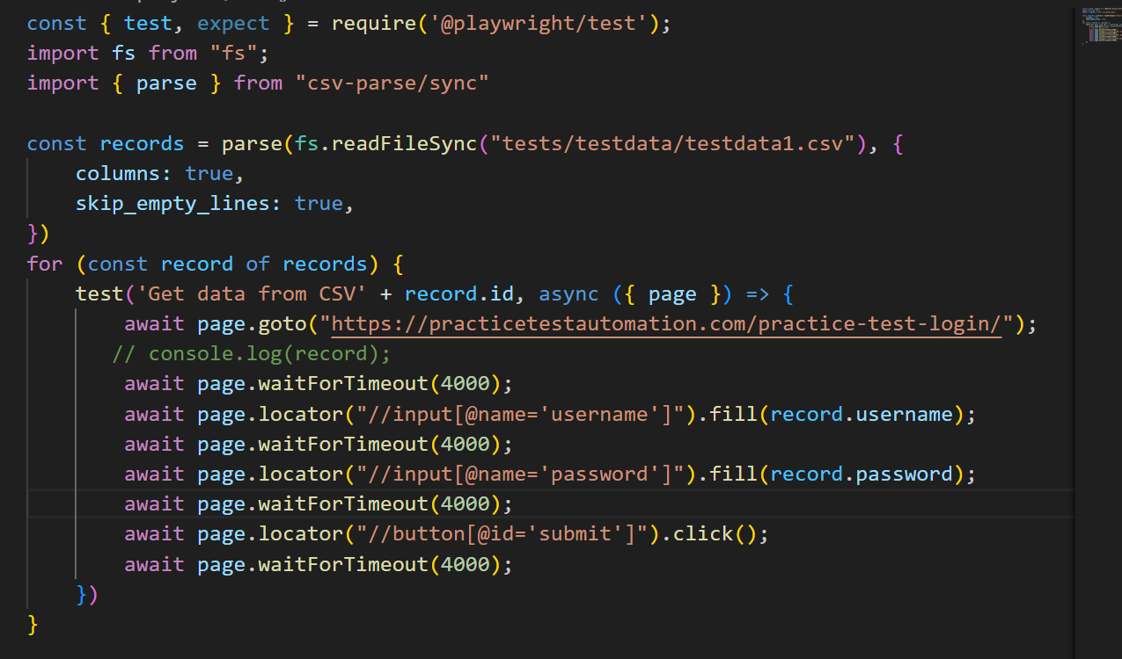
Create one file
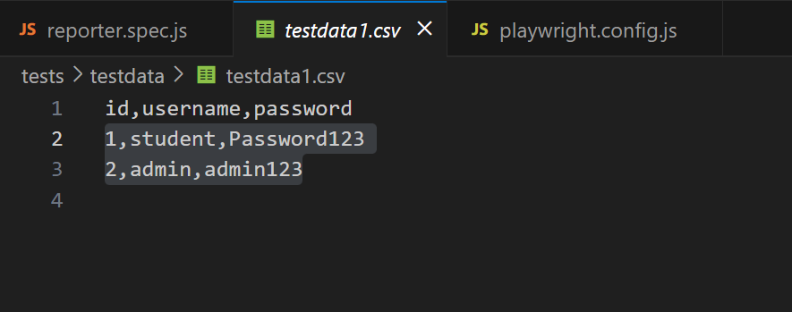
Command to install parse ---->
1) npm install -save csv-parse
2) npm i csv-parse

Report preparation for testscript-
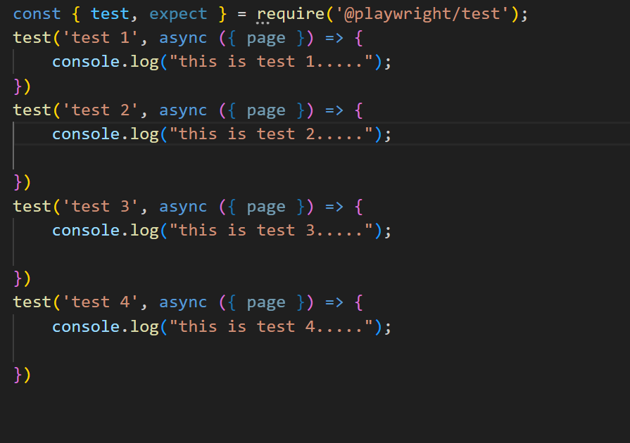
Report preparation commands--
- npx playwright test reporter.spec.js --project=chromium --reporter=json
- npx playwright test reporter.spec.js --project=chromium --reporter=html
- npx playwright test reporter.spec.js --project=chromium --reporter=dot
- npx playwright test reporter.spec.js --project=chromium --reporter=line
- npx playwright test reporter.spec.js --project=chromium --reporter=list
- Reporters | Playwright
Playwright config.js file setting for report -----
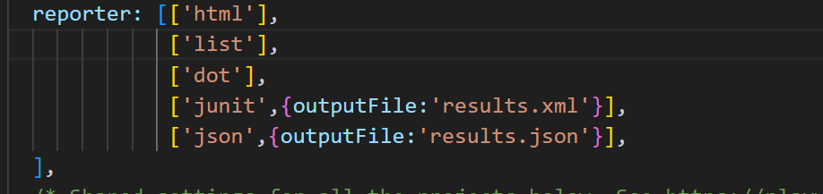
Thank You

